PIZZA SALES SQL QUERIES

A.KPI’s
1.TOTAL REVENUE:
SELECT SUM(total_price) AS TOTAL_REVENUE FROM pizza_sales

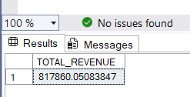
2.AVERAGE_ORDER_VALUE:
SELECT SUM(total_price)/COUNT(DISTINCT order_id) AS AVERAGE_ORDER_VALUE FROM pizza_sales
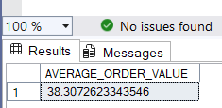

3.Total_Pizza_sold:
SELECT SUM(quantity) AS Total_Pizza_sold FROM pizza_sales
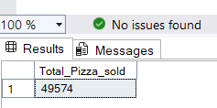

4.Total_Orders:
SELECT COUNT(DISTINCT order_id) AS Total_Orders FROM pizza_sales
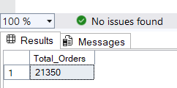

5.Average_Pizza_Per_Order:
SELECT CAST(SUM(quantity) AS decimal(10,2))/CAST(COUNT(DISTINCT order_id) AS decimal(10,2)) AS Average_Pizza_Per_Order FROM pizza_sales
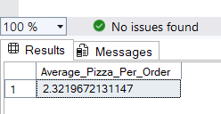

6.DAILY Trends:
SELECT DATENAME(DW, order_date) as order_day, COUNT(DISTINCT order_id) as Total_orders
from pizza_sales
GROUP BY DATENAME(DW, order_date)
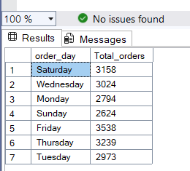

7. Hourly Trend
SELECT DATEPART(HOUR, order_time) AS order_hours, COUNT(DISTINCT order_id) as Total_orders from pizza_sales
GROUP BY DATEPART(HOUR, order_time)
ORDER BY DATEPART(HOUR, order_time)
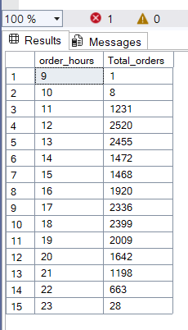
7. Percentage of Categories
SELECT pizza_category,SUM(total_price) as Total_sales ,SUM(total_price)*100/(SELECT SUM(total_price) from pizza_sales) as PCT from pizza_sales
GROUP BY pizza_category

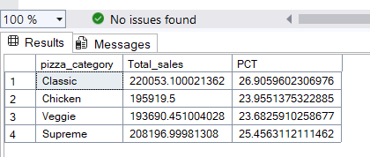
7. Percentage of Sizes
SELECT pizza_size,SUM(total_price) as Total_sales ,SUM(total_price)*100/(SELECT SUM(total_price) from pizza_sales) as PCT from pizza_sales
GROUP BY pizza_size
ORDER BY pizza_size
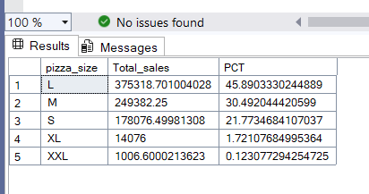

8.Sales in Each Category
SELECT pizza_category, SUM(quantity) as Total_Pizzas_sold
from pizza_sales
Group BY pizza_category
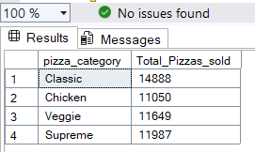

9.Pizza sold
SELECT TOP 5 pizza_name, SUM(quantity) as Total_Sold
from pizza_sales
GROUP BY pizza_name
order by SUM(quantity) DESC

